README FILE
Grazioso Salvare Rescue Dog Dashboard
CS-340 Client/Server Development – Project Two
Developer: Aero Berry
Date: 02/22/26

Project Overview

This project was developed for Grazioso Salvare, an international rescue animal training organization, as part of a full-stack client/server application. The goal of the application is to help identify dogs from animal shelter data that are suitable candidates for different types of search-and-rescue training. The application consists of a MongoDB database and a Python-based web dashboard that allows users to filter, view, and visualize animal shelter data in an intuitive and user-friendly way. The dashboard enables Grazioso Salvare staff to quickly identify dogs that meet specific rescue training criteria based on breed, age, and sex. This project demonstrates the application of database systems concepts, client/server development, and interactive data visualization.

Required Functionality
The dashboard provides the following required features:
- Interactive filtering options to select dogs suitable for:
  - Water Rescue
  - Mountain or Wilderness Rescue
  - Disaster or Individual Tracking
  - Reset (unfiltered data)
- A dynamic data table that updates based on selected filters
- A geolocation map that displays the location of selected animals
- A secondary pie chart that visualizes breed distribution
- Inclusion of the Grazioso Salvare logo and my unique identifier identifying me as the developer
All dashboard components update dynamically in response to the user’s interaction.

Dashboard Screenshots
1. Dashboard – Reset (Unfiltered State)
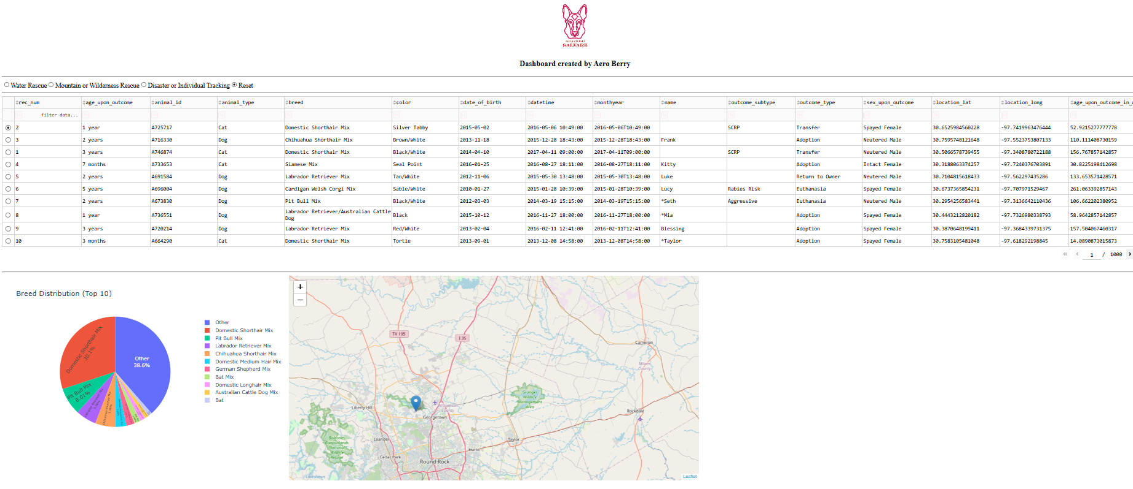
Description:
This screenshot shows the dashboard in its initial state with no filters applied. All animals from the database are displayed in the data table, along with the geolocation map and breed distribution chart.

2. Dashboard – Water Rescue Filter Applied
Description:
This screenshot demonstrates the Water Rescue filter. The dashboard displays only dogs that match the Water Rescue criteria, including preferred breeds, age range, and sex.
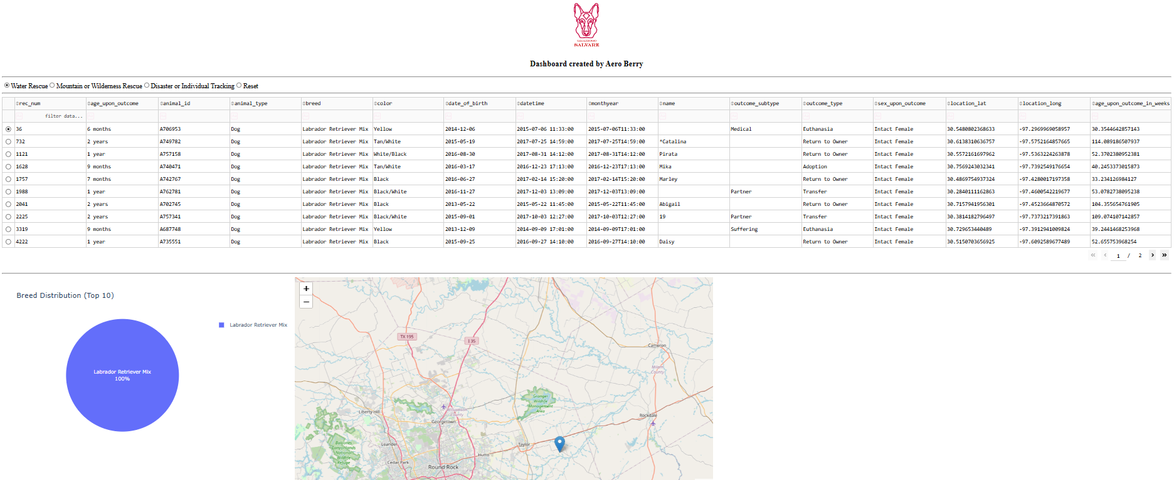
3. Dashboard – Mountain or Wilderness Rescue Filter Applied
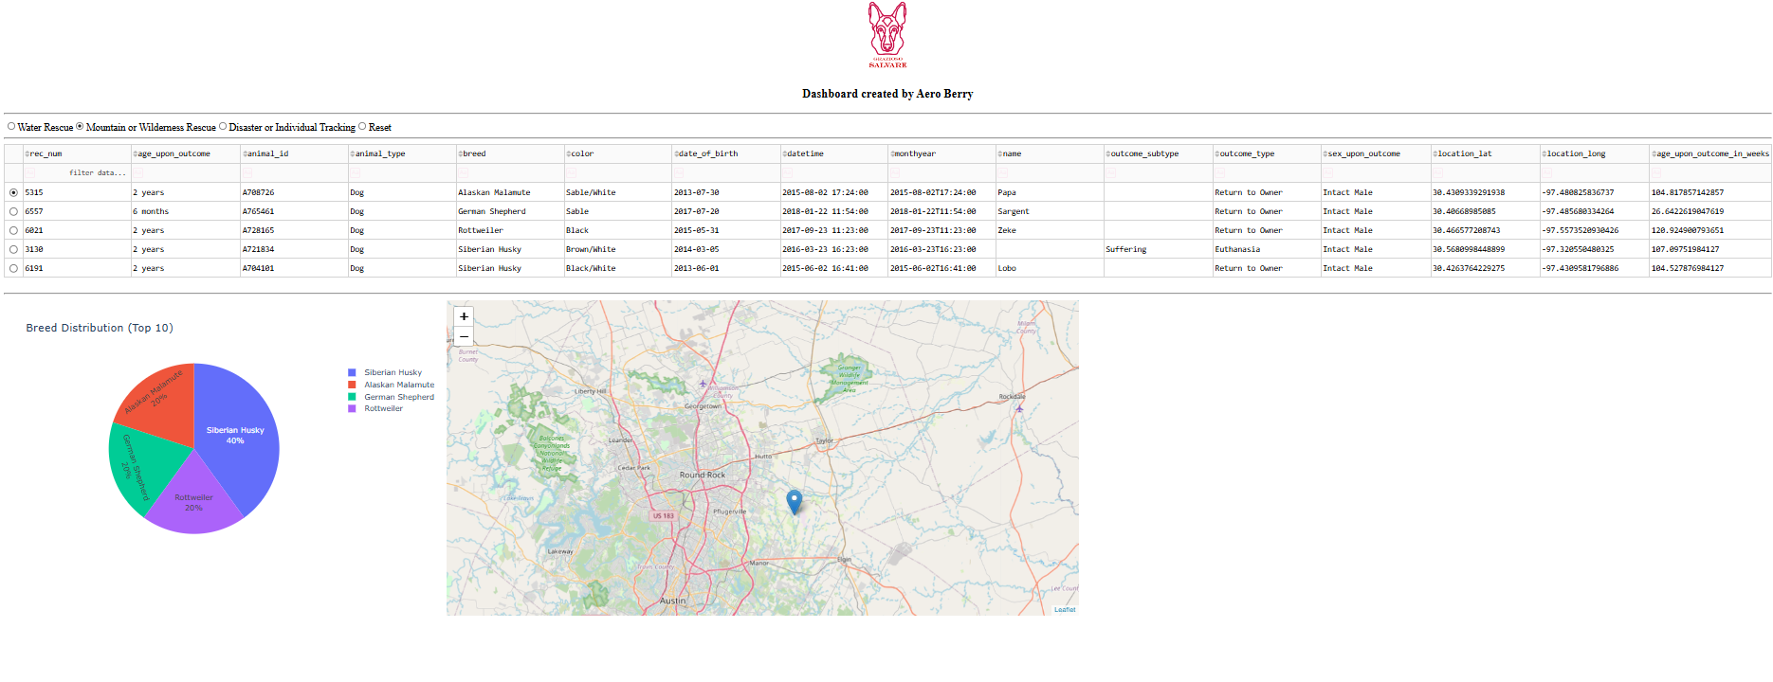
Description:
This screenshot shows the Mountain or Wilderness Rescue filter in use. The data table, geolocation map, and pie chart dynamically update to reflect only dogs suitable for mountain or wilderness rescue training.

4. Dashboard – Disaster or Individual Tracking Filter Applied
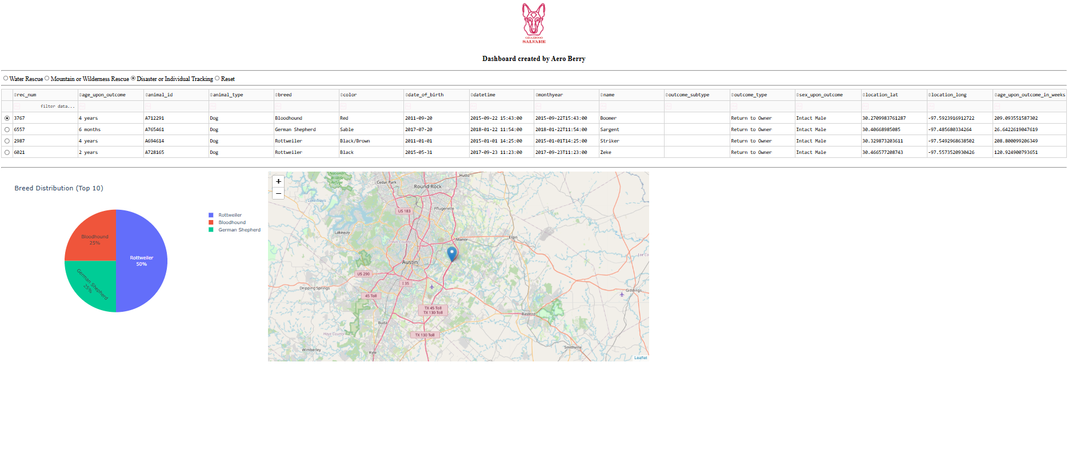
Description:
This screenshot demonstrates the Disaster or Individual Tracking filter. The dashboard updates to show dogs that meet the criteria for disaster response or individual tracking training.

Tools and Technologies Used:
MongoDB
MongoDB was used as the database component of the application. It was selected because it is a flexible, document-oriented NoSQL database that integrates well with Python. MongoDB allows data to be stored as JSON-like documents, which makes it easy to query, filter, and manipulate structured animal shelter data. MongoDB also works efficiently with large datasets and supports flexible schema design, which is ideal for evolving data requirements.
Python and PyMongo
Python was used to develop the CRUD module that interfaces directly with MongoDB. PyMongo provides a clean and efficient way to execute database queries from Python code. The custom CRUD Python module acts as the controller layer between the database and the dashboard, ensuring separation of concerns and modular design.
Dash Framework
The Dash framework was used to build the web application dashboard. Dash provides both the view and controller components of the application and allows Python developers to create interactive web applications without requiring JavaScript.
Dash was chosen because:
- It integrates seamlessly with Python and Pandas
- It supports interactive components such as data tables, radio buttons, and charts
- It enables real-time updates to dashboard components through callbacks

Additional Libraries (etc)
- Pandas: Used for data manipulation and transformation
- Plotly Express: Used to create dynamic charts
- Dash Leaflet: Used to create the geolocation map
- Base64: Used to embed the Grazioso Salvare logo in the dashboard

Steps Taken to Complete the Project
- Imported the Austin Animal Center Outcomes dataset into MongoDB
- Developed a Python CRUD module to interact with the MongoDB database
- Created an unfiltered data table using Dash
- Implemented interactive filtering options using radio buttons
- Developed MongoDB queries based on rescue type requirements
- Connected dashboard components using Dash callbacks
- Added a geolocation map to visualize animal locations
- Created a pie chart to visualize breed distribution
- Included the Grazioso Salvare logo and a unique developer identifier
- Tested the dashboard and captured screenshots demonstrating functionality

Challenges Encountered and Solutions
Challenge 1: Large Number of Breed Values
The dataset contained many unique dog breeds, which caused the pie chart to become cluttered and difficult to read.
Solution:
I modified the pie chart to display only the top ten most common breeds, with all remaining breeds grouped into an “Other” category. This improved readability while maintaining accurate data representation.

Challenge 2: File Path Issues with Logo Image
The application initially failed to load the logo due to file path issues.
Solution:
This was quickly fixed as I didn’t account for the spaces in the filename, and I made a typo by putting based64 instead of base64 in the code line.

How to Reproduce This Project
- Install MongoDB and ensure the MongoDB server is running
- Import the Austin Animal Center Outcomes dataset into MongoDB
- Ensure the MongoDB user credentials match those used in the CRUD module
- Install required Python libraries:
  - dash
  - dash-leaflet
  - pandas
  - plotly
  - pymongo
- Run the ProjectTwoDashboard.ipynb notebook in JupyterLab or Codio
- Access the dashboard through the generated local server link

Conclusion
This project successfully demonstrates the development of a full-stack client/server application using MongoDB, Python, and Dash. The final dashboard meets all client requirements and provides an intuitive interface for identifying rescue dog candidates based on real-world data. The modular design and open-source approach allow the application to be easily extended or adapted for similar organizations.

